**Pendulum: Measurement of the Acceleration of Gravity and Angle of Release**

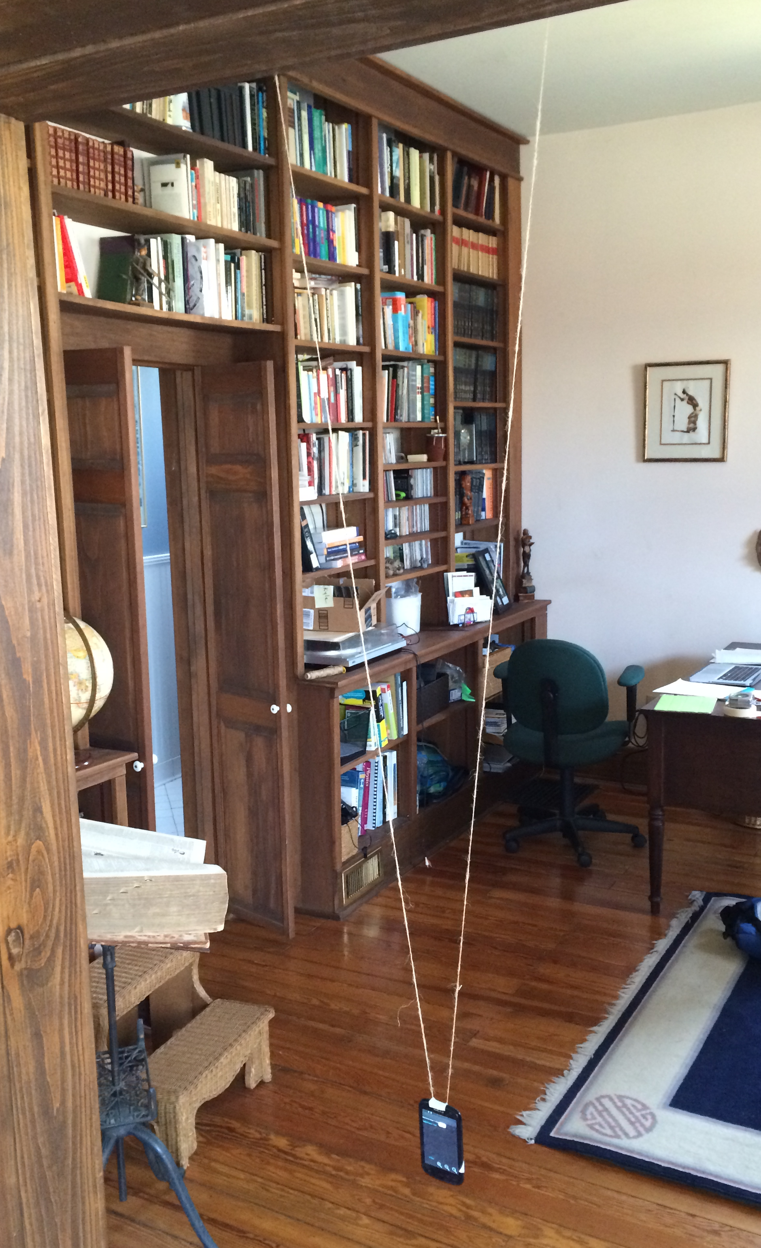The period of a pendulum is given by $T=2π\sqrt{\frac{l}{g}}$ where *l* is the length of the pendulum and $g$ is the acceleration of gravity. If the period, $T,$ is measured accurately and the pendulum length *l* known, the acceleration of gravity can be calculated.

**Acceleration of gravity**

Procedure:

1. From the top of a doorway, fasten the two ends of a 3 m string approximately 30 cm apart so that the lowest point of the loop is at least 20 cm above the floor.
2. Tape the top of the phone or tablet to the center of the string loop so that it hangs straight down as shown in the picture on the right.
3. Measure the vertical distance from the center of the device to the height of the string. This is *l*, the length of the pendulum.
4. Start the *Pendulum* app*. Tap *Collect* to open the *Physics Toolbox* app+. The app will graph the total acceleration in real time; the *y* acceleration should be about 1g when hanging and stationary.
5. With the string tight, pull the device back to a height of about 1 m at the same angle as the string. Tap the *Record* button. Wait a second and let the device swing six times or more. Tap *Stop* to save acceleration data for analysis.
6. The *Physics Toolbox* screen should be similar to the figure below, but without the red *a, b, c, d, e* letters – see the second part of the lab for an explanation.

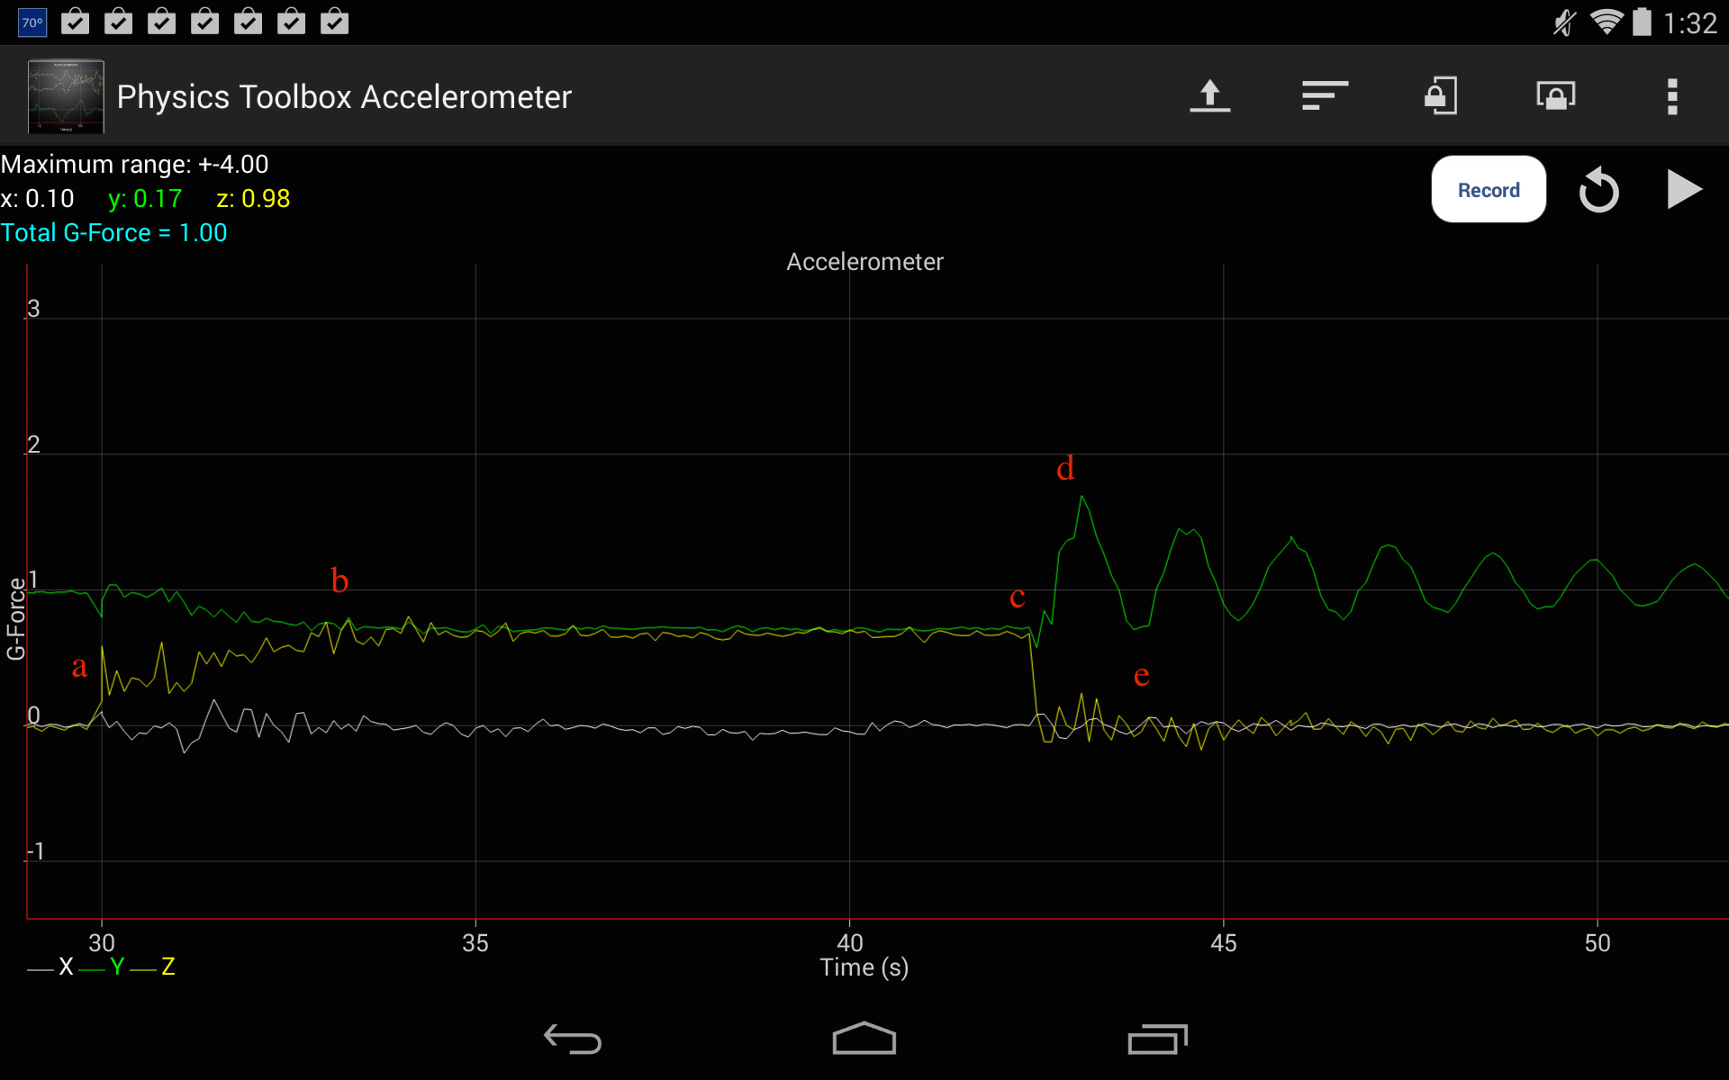

1. 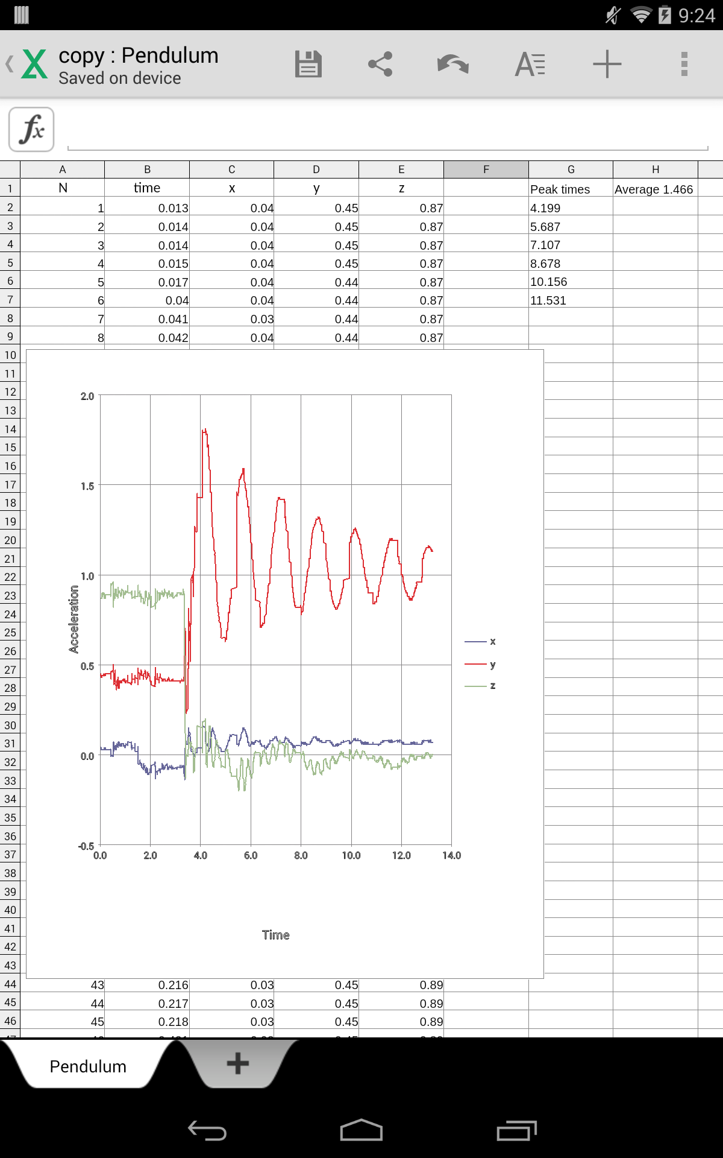 The *y* accelerometer is measuring centripetal acceleration plus gravity which is a maximum at the bottom of the pendulum swing. So the peaks (maximums) in the acceleration graph occur when the device passes through the lowest point of the swing. This occurs twice in order for the pendulum to return to its original location. Therefore, the time between two successive peaks in the *y* acceleration graph is half the period, $T$.
2. Tap the back button to return to the Pendulum app, then choose *Analyze*. The app loads the data into a spreadsheet using the file *Pendulum/input.xls* as a template and results to *Pendulum/copy.xls*. Your results should be similar to the figure at right; the average peak-to-peak time is calculated from the data.
3. Calculate $g=l{\left(\frac{2π}{T}\right)}^{2}$.

**Angle of Release and Centripetal acceleration**

The measurement of the period can be done with a stopwatch. However, the acceleration app (Physics Toolbox) can provide much more information.

The points labeled on the graph below correspond to the following actions (remember the accelerometer measures force whether from gravity or acceleration):

1. Phone is hanging straight down; *x* and *z* accelerometers are zero, *y* accelerometer is 1 $g$.
2. Device is held at angle, $θ$; *x* accelerometer still is zero but *y* and *z* both are about 0.7 $g$ for this angle. The device is held at this angle until point *c*.
3. Device is released.
4. Device passes through the lowest point of the swing; *x* and *z* accelerometers are zero, *y* accelerometer is a maximum.
5. Device reaches the other side of the swing; *y* accelerometer is approximately the same as at the initial angle.
6. Device passes though the lowest point on its return; *y* is a maximum.
7. The oscillations repeat but are smaller due to friction.

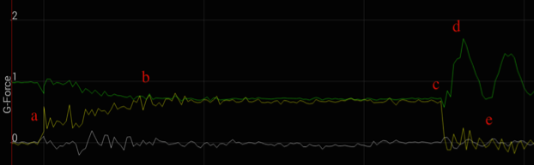

The figure below shows the forces acting on the device. You may have realized that the device measures a total acceleration of (= 9.8 m/s2) when it is stationary. The acceleration of gravity, $g$, must be included when using the acceleration measurements to calculate the true acceleration of the device. Only then can the acceleration measurements be used to determine the angle, $θ$, and the speed of the device as it passes the lowest point.

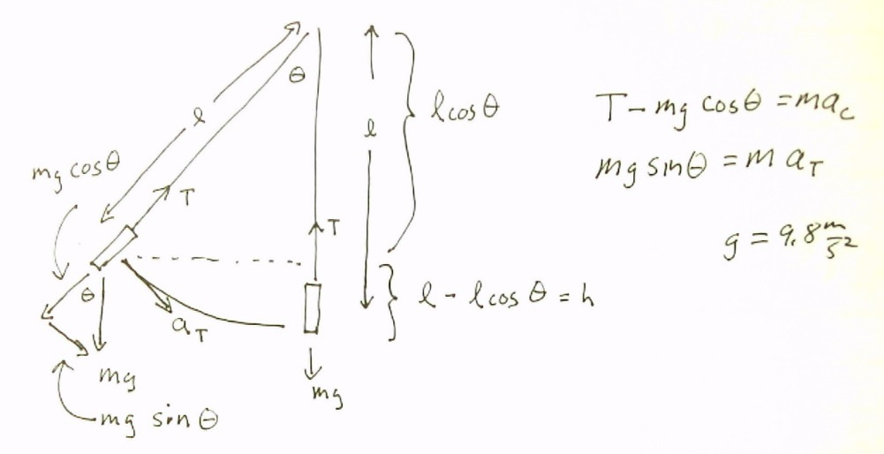

Procedure:

1. The angle of release is given by $gsinθ=a_{T}$ where $a_{T}$ is the acceleration in the z direction. For the last data set, zoom in to find the *z* acceleration between points *b* and *c* (when the device is being held at a constant angle before release). Calculate the release angle, $θ$, from this acceleration.
2. At the bottom of the swing the y acceleration as measured by the device includes the value of $g$ when stationary. Subtracting gravity, $g$, gives the centripetal acceleration, $a_{c}$. Calculate the centripetal acceleration using the maximum *y* acceleration in the first swing and subtracting $g$.
3. The velocity at the bottom can be determined two ways. First use the fact that the centripetal acceleration just calculated is $a_{c}=v_{T}^{2}/r$ where $r$ is the pendulum length and $v_{T}$ is the velocity at the bottom. Calculate the velocity using the centripetal acceleration.
4. Check your answer by using conservation of energy, $\frac{1}{2}mv_{T}^{2}=mgh$ where $h=l(1-cosθ)$. This theoretical answer for $v_{T}$ will be slightly higher than the measured value because some energy is lost due to friction.

*Mobile Science Pendulum app: <https://play.google.com/store/apps/details?id=edu.ius.pendulum>

+Physics Toolbox app: <https://play.google.com/store/apps/details?id=com.chrystianvieyra.android.physicstoolboxaccelerometer>

#Check your release angle result, $θ$, using Bubble Level app:

<https://play.google.com/store/apps/details?id=net.androgames.level>